**COAL LAB5, 23K-0842, KINZA**

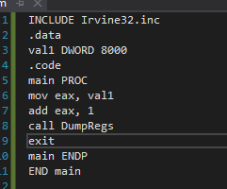 **Carry Flag: 0, Sign Flag: 0**

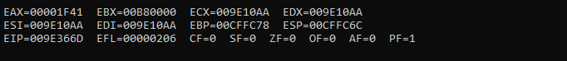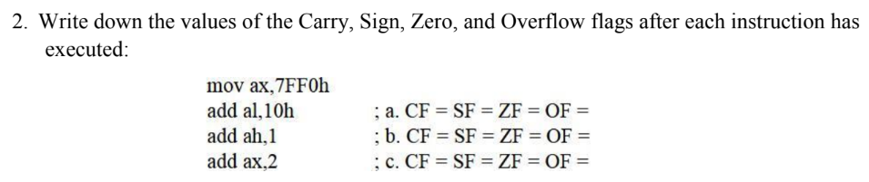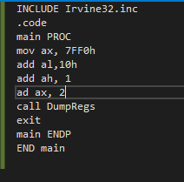

OV = 0 UP = 0 EI = 1 PL = 0 ZR = 1 AC = 0 PE = 1 CY = 0

**a.** CF=1, SF=0, ZF=1, OF=0

**b.** CF=0, SF=1, ZF=0, OF =1

**c.** CF=0, SF=1, ZF=0, OF=0

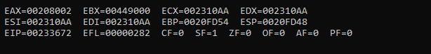

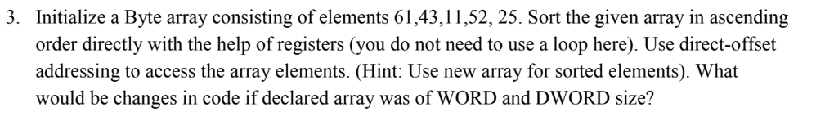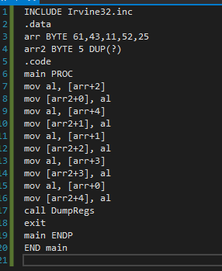

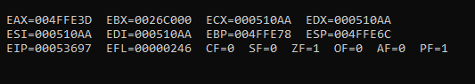

If declared array was WORD index would be incremented by 2 to access each location: arr+0, arr+2, arr+4, arr+8, arr+10 etc.

If declared array was DWORD index would be incremented by 4 to access each location: arr+0, arr+4, arr+8, arr+12, arr+16 etc.

**WORD:**

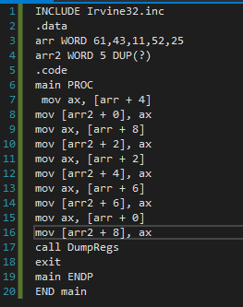

**DWORD:**

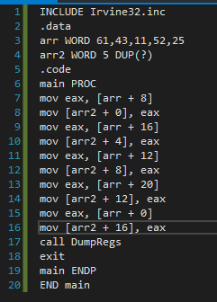

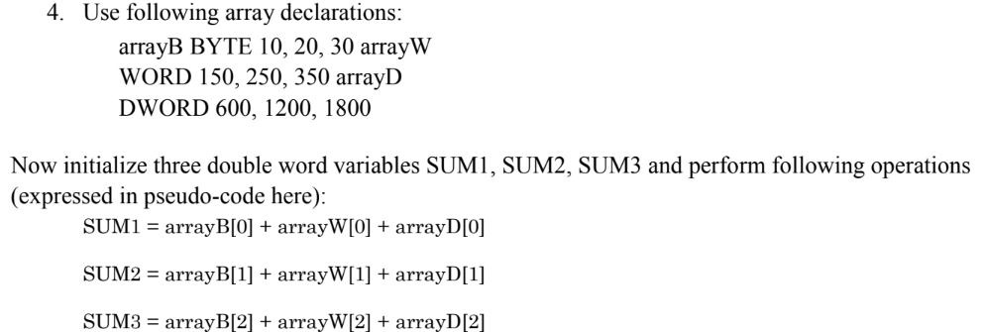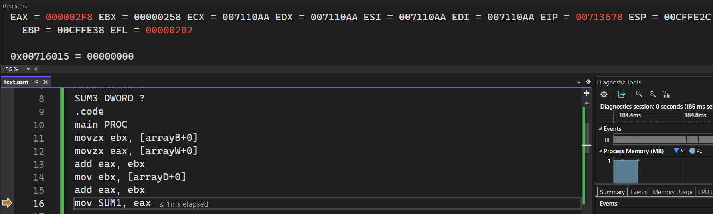SUM1: 000002F8h

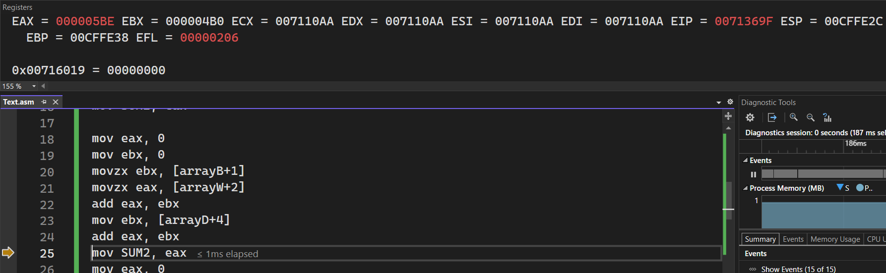SUM2: 000005BEh SUM3: 00000884h

